Experiment No. 10

Aim : Implementation of different types of event handling

- GUI Program to display the current mouse coordinates on the window.
import javax.swing.*;
import java.awt.event.*;

public class MouseCoordinates extends JFrame implements MouseMotionListener {

JLabel label;

public MouseCoordinates() {
setTitle("Mouse Coordinates Tracker");
setSize(400, 300);
setDefaultCloseOperation(JFrame.EXIT_ON_CLOSE);
setLayout(null);

label = new JLabel("Move mouse inside window...");
label.setBounds(100, 120, 250, 30);
add(label);

addMouseMotionListener(this);

setVisible(true);
}

@Override
public void mouseMoved(MouseEvent e) {
int x = e.getX();
int y = e.getY();
label.setText("X: " + x + " , Y: " + y);
}

@Override
public void mouseDragged(MouseEvent e) {
// Optional: handle drag if needed
}

public static void main(String[] args) {
new MouseCoordinates();
}
}

OUTPUT :

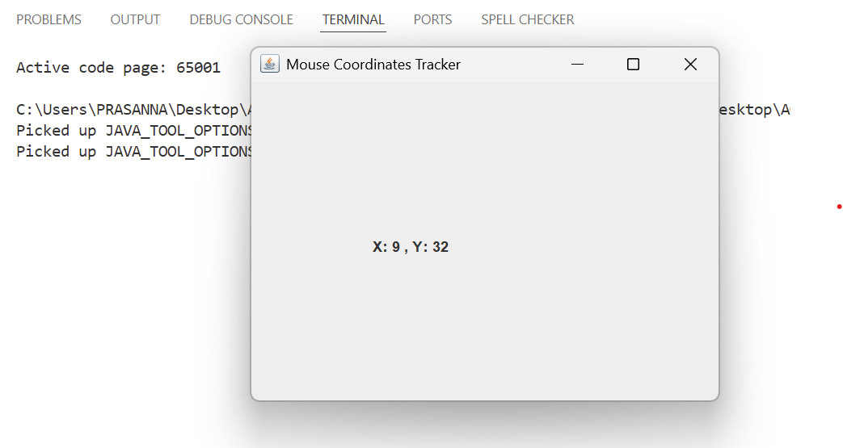

2. GUI Program to implement a simple Timer (using background events). Include a Start and Stop button to control the timer.
import javax.swing.*;
import java.awt.event.*;

public class SimpleTimer extends JFrame implements ActionListener {

JLabel timeLabel;
JButton startBtn, stopBtn;

int seconds = 0;
Timer timer;

public SimpleTimer() {
setTitle("Simple Timer");
setSize(300, 200);
setLayout(null);
setDefaultCloseOperation(JFrame.EXIT_ON_CLOSE);

timeLabel = new JLabel("Time: 0 sec");
timeLabel.setBounds(90, 40, 150, 30);
add(timeLabel);

startBtn = new JButton("Start");
startBtn.setBounds(50, 100, 80, 30);
add(startBtn);

stopBtn = new JButton("Stop");
stopBtn.setBounds(150, 100, 80, 30);
add(stopBtn);

// Timer fires every 1000 ms (1 second)
timer = new Timer(1000, new ActionListener() {
@Override
public void actionPerformed(ActionEvent e) {
seconds++;
timeLabel.setText("Time: " + seconds + " sec");
}
});

startBtn.addActionListener(this);
stopBtn.addActionListener(this);

setVisible(true);
}

@Override
public void actionPerformed(ActionEvent e) {
if (e.getSource() == startBtn) {
timer.start();
} else if (e.getSource() == stopBtn) {
timer.stop();
}
}

public static void main(String[] args) {
new SimpleTimer();
}
}

OUTPUT :
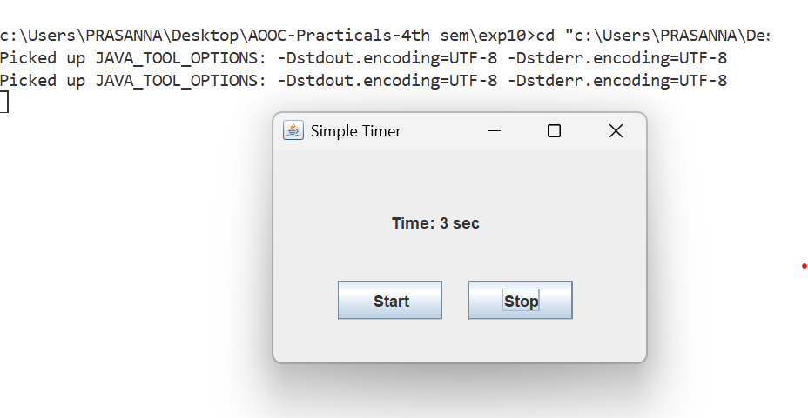
- Create a GUI with a JComboBox containing image names. On selection, display the corresponding image using a JLabel and ItemListener.

import javax.swing.*;
import java.awt.*;
import java.awt.event.ItemEvent;
import java.awt.event.ItemListener;
import java.util.HashMap;
import java.util.Map;

public class ImageViewerApp extends JFrame {

private JComboBox<String> imageComboBox;
private JLabel imageLabel;
private Map<String, String> imagePaths;

public ImageViewerApp() {
// Set up the main frame
setTitle("ComboBox Image Viewer");
setDefaultCloseOperation(JFrame.EXIT_ON_CLOSE);
setLayout(new BorderLayout(10, 10));

// 1. Initialize our image data mapping (Name -> File Path)
imagePaths = new HashMap<>();
imagePaths.put("Select an image...", "");
imagePaths.put("Puppy", "puppy.jpg");
imagePaths.put("Kitten", "kitten.jpg");
imagePaths.put("Parrot", "parrot.jpg");

// 2. Create the JComboBox with the image names
String[] imageNames = { "Select an image...", "Puppy", "Kitten", "Parrot" };
imageComboBox = new JComboBox<>(imageNames);

// 3. Create the JLabel to hold the image
imageLabel = new JLabel("Please select an image above.", SwingConstants.CENTER);
imageLabel.setPreferredSize(new Dimension(400, 300));

// Optional: add a border for better visual presentation
imageLabel.setBorder(BorderFactory.createLineBorder(Color.GRAY));

// 4. Add the ItemListener to the JComboBox
imageComboBox.addItemListener(new ItemListener() {
@Override
public void itemStateChanged(ItemEvent e) {
// Ensure we only react to the new item being selected,
// ignoring the deselection of the previous item.
if (e.getStateChange() == ItemEvent.SELECTED) {
String selectedName = (String) e.getItem();
updateImage(selectedName);
}
}
});

// 5. Add components to the frame
// Pad the layout a bit for aesthetics
JPanel topPanel = new JPanel();
topPanel.add(new JLabel("Choose Image: "));
topPanel.add(imageComboBox);

add(topPanel, BorderLayout.NORTH);
add(new JScrollPane(imageLabel), BorderLayout.CENTER);

// Pack and center the window on screen
pack();
setLocationRelativeTo(null);
}

/**
* Helper method to update the JLabel's icon based on the dropdown selection.
*/
private void updateImage(String imageName) {
String filePath = imagePaths.get(imageName);

if (filePath != null && !filePath.isEmpty()) {
ImageIcon icon = new ImageIcon(filePath);

// Check if the image was successfully loaded
if (icon.getIconWidth() == -1) {
imageLabel.setIcon(null);
imageLabel.setText("Image not found: " + filePath);
} else {
imageLabel.setIcon(icon);
imageLabel.setText(""); // Clear the text when an image is shown
}
} else {
// Revert to default text if "Select an image..." is chosen
imageLabel.setIcon(null);
imageLabel.setText("Please select an image above.");
}
}

public static void main(String[] args) {
// Run the GUI creation on the Event Dispatch Thread (EDT) for thread safety
SwingUtilities.invokeLater(new Runnable() {
@Override
public void run() {
new ImageViewerApp().setVisible(true);
}
});
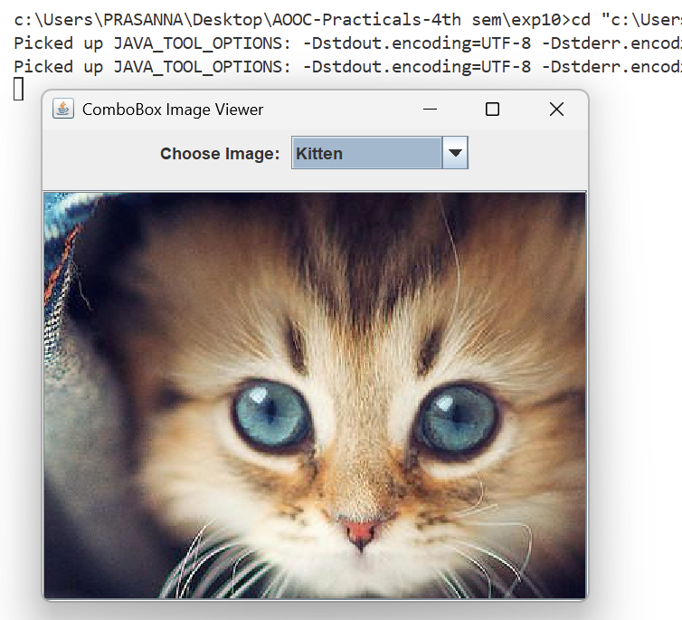
}
}

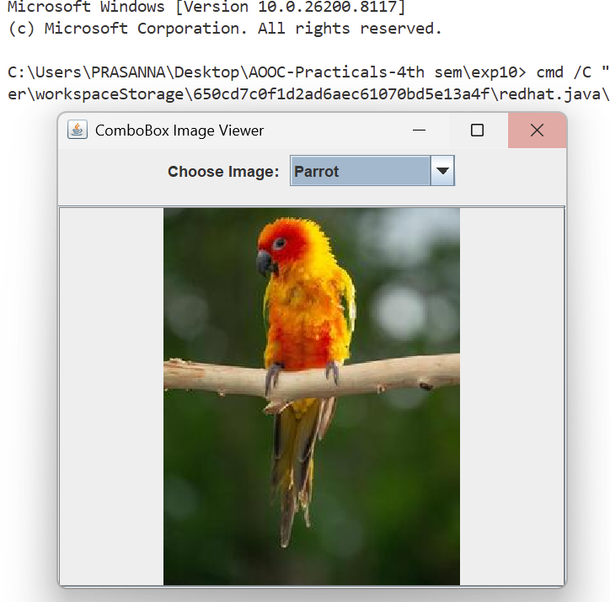
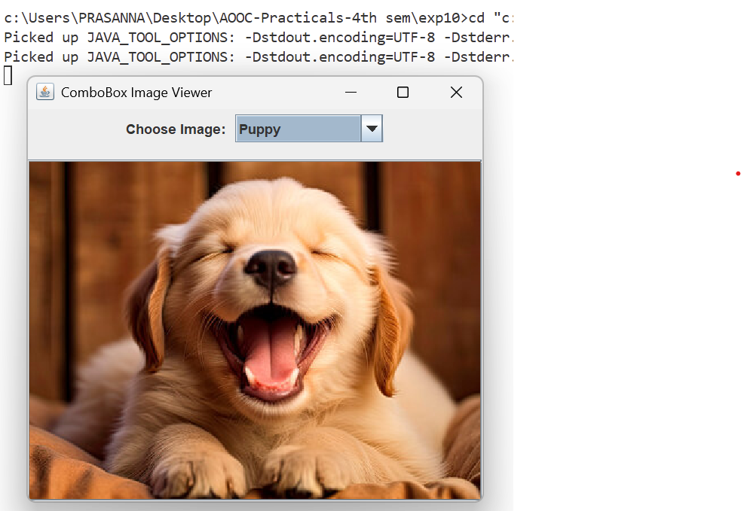

4. GUI with a JTextArea and a label. As the user types, show the character count and word count in real-time using a KeyListener
import javax.swing.*;
import java.awt.*;
import java.awt.event.KeyEvent;
import java.awt.event.KeyListener;

public class WordCharacterCounter extends JFrame implements KeyListener {

private JTextArea textArea;
private JLabel countLabel;

public WordCharacterCounter() {
setTitle("Real-Time Word & Character Counter");
setSize(500, 400);
setDefaultCloseOperation(JFrame.EXIT_ON_CLOSE);
setLayout(new BorderLayout(10, 10));

// Initialize JTextArea
textArea = new JTextArea();
textArea.setLineWrap(true);
textArea.setWrapStyleWord(true);
textArea.setFont(new Font("Arial", Font.PLAIN, 14));

// Add the KeyListener to the text area
textArea.addKeyListener(this);

// Initialize JLabel for counts
countLabel = new JLabel("Characters: 0 | Words: 0");
countLabel.setFont(new Font("Arial", Font.BOLD, 14));
countLabel.setBorder(BorderFactory.createEmptyBorder(5, 10, 10, 10));
countLabel.setHorizontalAlignment(SwingConstants.CENTER);

// Add components to the frame
// A JScrollPane is highly recommended for text areas to allow scrolling
add(new JScrollPane(textArea), BorderLayout.CENTER);
add(countLabel, BorderLayout.SOUTH);

setLocationRelativeTo(null); // Center the window on the screen
}

@Override
public void keyTyped(KeyEvent e) {
// Not used, but required by KeyListener interface
}

@Override
public void keyPressed(KeyEvent e) {
// Not used, but required by KeyListener interface
}

@Override
public void keyReleased(KeyEvent e) {
// keyReleased is ideal because the text component has already updated its
// content
String text = textArea.getText();

int charCount = text.length();
// Trim the text and split by whitespace to get the word count
int wordCount = text.trim().isEmpty() ? 0 : text.trim().split("\\s+").length;

countLabel.setText("Characters: " + charCount + " | Words: " + wordCount);
}

public static void main(String[] args) {
SwingUtilities.invokeLater(() -> new WordCharacterCounter().setVisible(true));
}
}

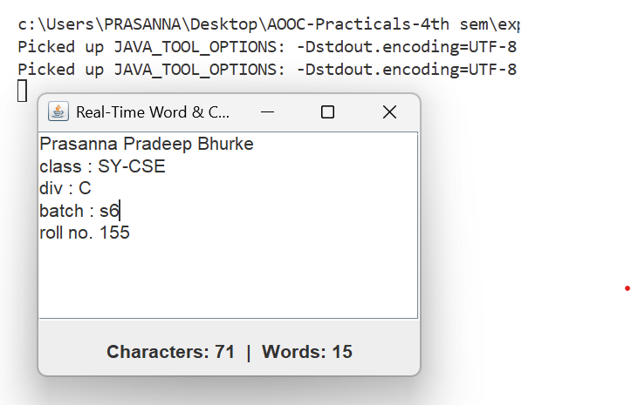

5. Write Java GUI Program using Swing to change background on selecting color.

import javax.swing.*;
import java.awt.*;
import java.awt.event.ActionEvent;
import java.awt.event.ActionListener;

public class BackgroundColorChanger extends JFrame {

private JComboBox<String> colorDropdown;
private JPanel mainPanel;

public BackgroundColorChanger() {
setTitle("Background Color Changer");
setSize(400, 300);
setDefaultCloseOperation(JFrame.EXIT_ON_CLOSE);

// Create main panel
mainPanel = new JPanel();
mainPanel.setLayout(new FlowLayout(FlowLayout.CENTER, 20, 20));

// Array of color names for the dropdown
String[] colorNames = { "White", "Red", "Green", "Blue", "Yellow", "Orange", "Pink", "Black" };
colorDropdown = new JComboBox<>(colorNames);

// Add an ActionListener to detect when a new color is selected
colorDropdown.addActionListener(new ActionListener() {
@Override
public void actionPerformed(ActionEvent e) {
String selectedColor = (String) colorDropdown.getSelectedItem();
changeBackgroundColor(selectedColor);
}
});

// Add components to the panel
mainPanel.add(new JLabel("Select Background Color: "));
mainPanel.add(colorDropdown);

// Add the main panel to the frame
add(mainPanel);

// Center the window on the screen
setLocationRelativeTo(null);
}

// Helper method to convert String selection to an actual java.awt.Color
private void changeBackgroundColor(String colorName) {
switch (colorName) {
case "Red":
mainPanel.setBackground(Color.RED);
break;
case "Green":
mainPanel.setBackground(Color.GREEN);
break;
case "Blue":
mainPanel.setBackground(Color.BLUE);
break;
case "Yellow":
mainPanel.setBackground(Color.YELLOW);
break;
case "Orange":
mainPanel.setBackground(Color.ORANGE);
break;
case "Pink":
mainPanel.setBackground(Color.PINK);
break;
case "Black":
mainPanel.setBackground(Color.BLACK);
break;
default:
mainPanel.setBackground(Color.WHITE);
break;
}
}

public static void main(String[] args) {
SwingUtilities.invokeLater(() -> new BackgroundColorChanger().setVisible(true));
}
}
